**Restaurants Reservation back-end service:**

**Abstract:**

There will be already guest, restaurant and table data will be available in DB.

So we do reservation of tables of restaurant with number of guests and reservation time by our API.

Here It have suppose the table will booked for 1 hour from time of reservation to keep application simple due to lack of time for development.

e.g. suppose reservation time is 22 Jan, 2019 10:00 am

So the table will be not allow booking between above time range.

It have considered most of the scenarios and the validation you have mentioned.

**Application is deployed on heroku:** https://restaurant-services.herokuapp.com/

**Note:** Please have a look at screen-shots for more information.

**API:**

**1: create a reservation**

URL: https://restaurant-services.herokuapp.com/api/v1/reservations

method: POST

params:

{

"guest_id" : 1,

"restaurant_id" : 1,

"table_id": 1,

"guest_count" : 4,

"reservation_time" : "22 jan 2019 12:00 pm"

}

**2: updates the reservation**

URL: https://restaurant-services.herokuapp.com/api/v1/reservations/<reservation_id>

method: PUT

params:

{

"reservation_time" : "23 jan 2019 12:00 pm",

"guest_count" : 5

}

**3: list of reservations for a restaurant**

URL: https://restaurant-services.herokuapp.com/api/v1/restaurants/<restaurant_id>

Method: GET

**API requests calling screen-shots:**

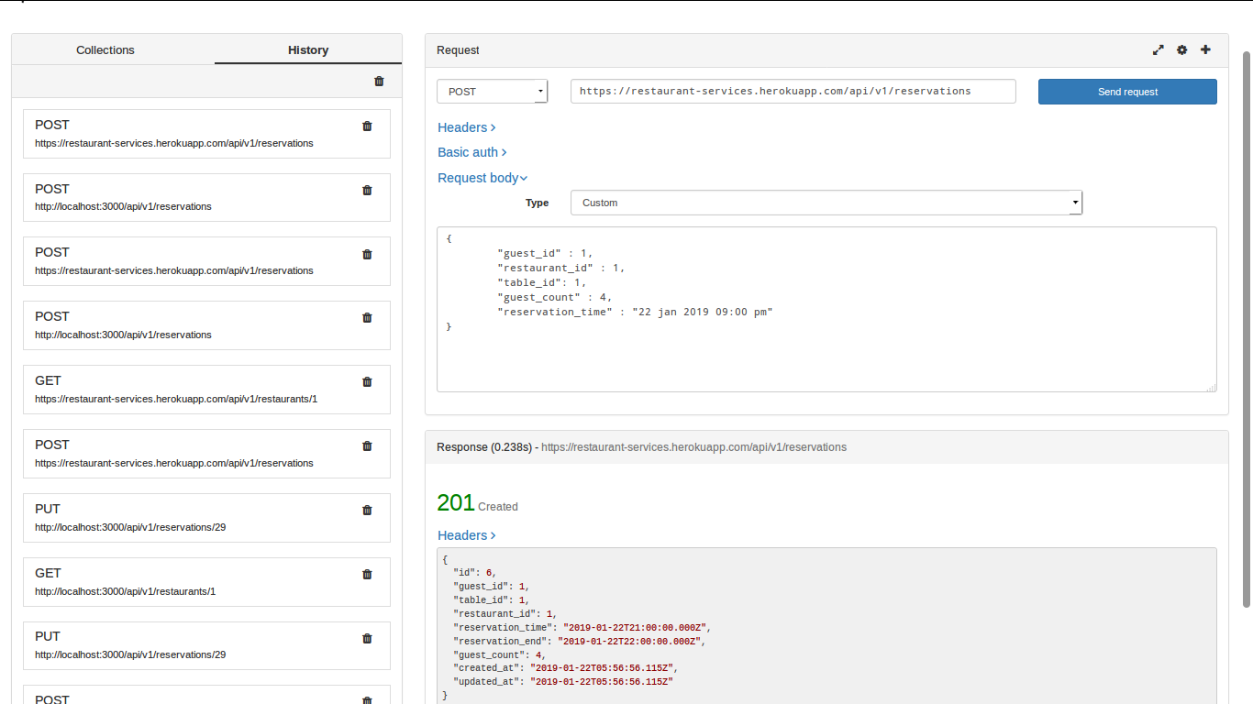

2.

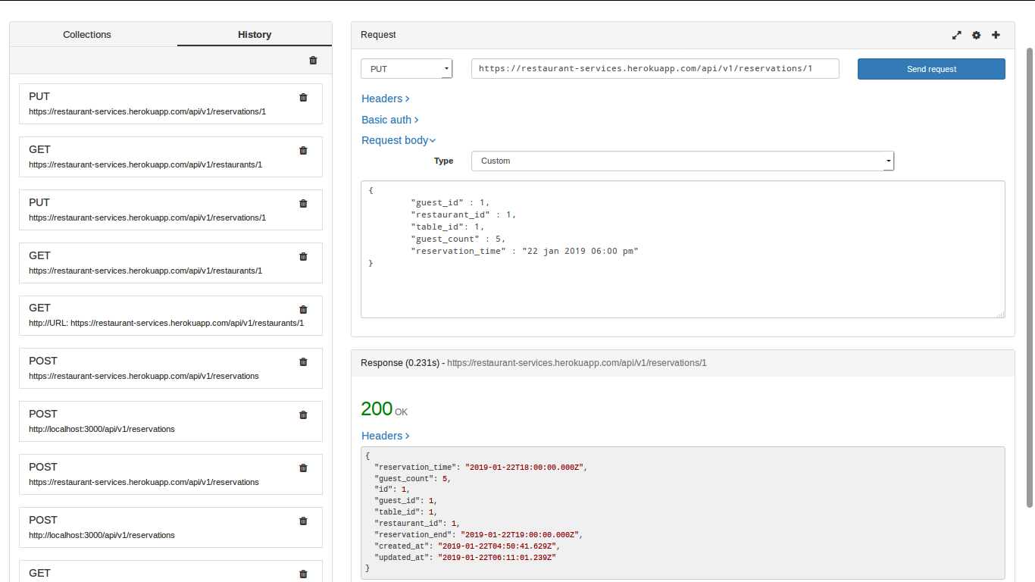

3.

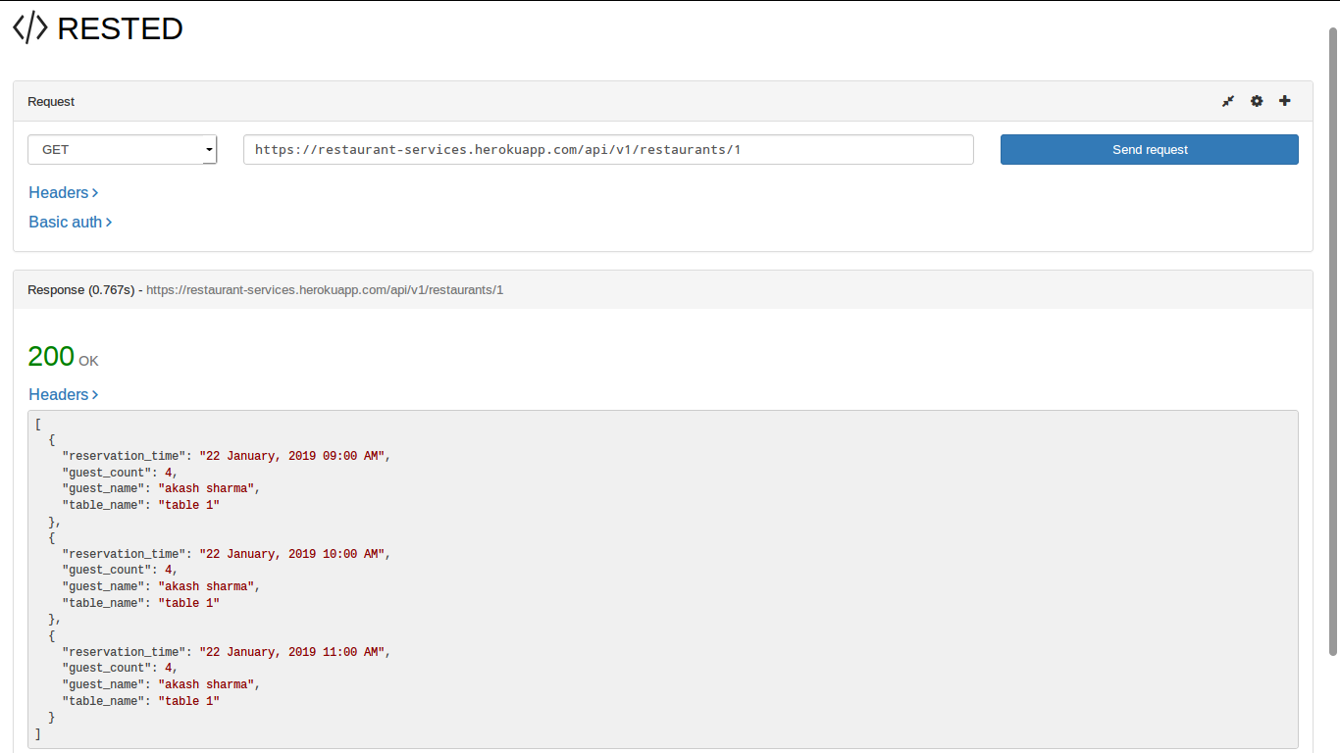

4.

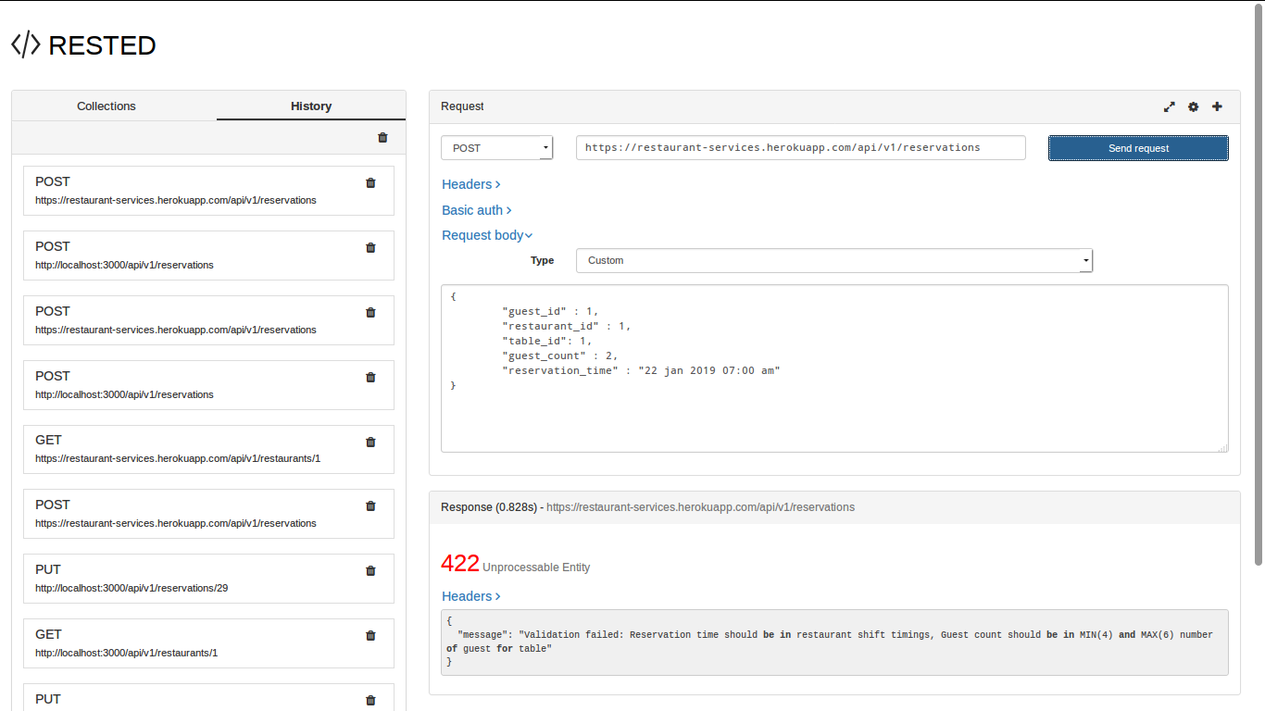

5.

